INTEGRATIVE COURSE IN PSYCHOLOGY (ICOPSYCH)

ANALYSIS ON THE RESULT OF PRE-TEST EXAMINATION IN DEVELOPMENTAL PSYCHOLOGY
May 10, 2025

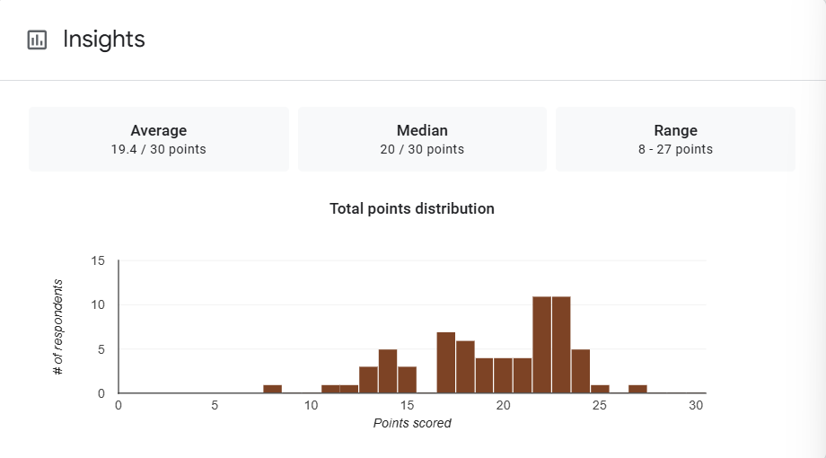

1. Mean Score: The mean score of 19.4 out of 30 is approximately 64.7%, suggesting a moderate level of performance overall. This indicates that while students generally grasped the material, there may have been challenges with some parts of the exam.

2. Median Score: The median score is 20 (≈66.7%), slightly higher than the mean. This suggests a slight negative skew, meaning a small number of lower scores are pulling the average down, while most students scored slightly above the mean.

3. Range: The range is 19 points, from a low of 8/30 (26.7%) to a high of 27/30 (90%). This reflects a wide spread in performance, indicating a diverse range of understanding among the students—some excelled, while others struggled significantly.

Interpretation Summary:

-The average performance (64.7%) was moderate, with the median (66.7%) suggesting that more than half the students scored in the mid-to-high range.

-The slight negative skew points to a few low-performing students affecting the overall mean.

-The broad range (8–27) reveals significant variability in student performance, highlighting differences in mastery of the material.
-Overall, the results indicate average to good performance for most students, but also point to a need for targeted support or intervention for those scoring in the lower range.

RATIONALIZATION:

DIFFICULT QUESTIONS:

